GIDDINGS & LEWIS
PiC Application Note

Document Number: AN000055

Topic: Digital MMC/Exter Application Quick Start Guide

The purpose of this application note is to provide a step by step example to establish communications between an Exter Terminal and a Digital MMC. This particular example is based on a single axis sales demo unit that is wired with drive I/O, general I/O, and block I/O. Modifications may be required to the software and/or hardware declarations depending on your hardware set up.

Index:

Establishing Serial Communication with an Exter Terminal and DMMC 2

Establishing Ethernet Communication with an Exter Terminal and DMMC 16

Initial Download of an Exter Terminal with Ethernet 32

Application Tips and Troubleshooting 37

Revision History 40
Establishing Serial Communication with an Exter Terminal and DMMC

Step 1:
Connect Programming Cable (M.1302.8284) to PC and DMMC.
Start PiCPro for Windows.
Open the file:
C:\Program Files\G&L Motion Control\Applications V16.0.1\Examples\Digital MMC Smart Drive 1 Axis Sales Demo\DemoD1Ex Pro Edition.PRJ

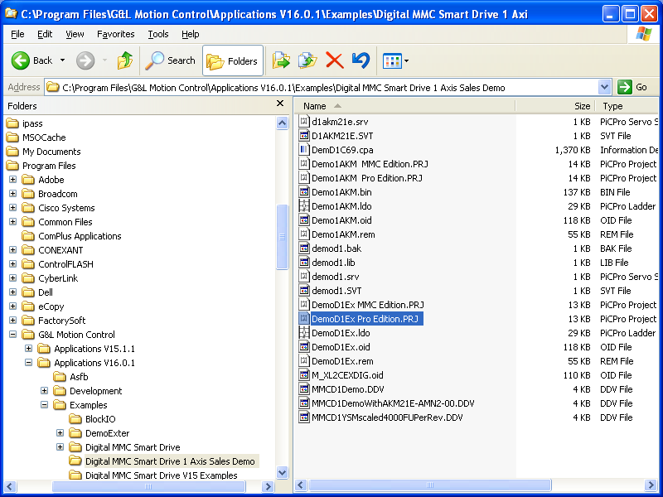
A project file similar to the one below will open. The folders can be expanded to provide information about the project. Three of the folders have been expanded in the example below.

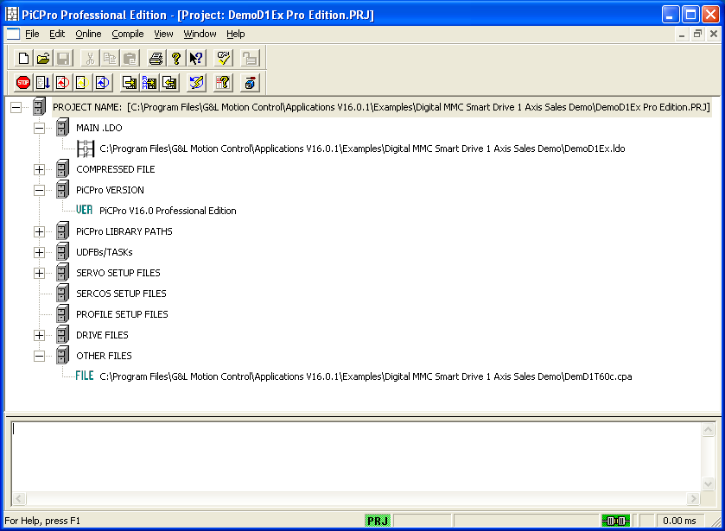
Step 2:
Select WINDOW and MAIN LADDER from the main menu bar. The ladder or LDO file will appear similar to the one below.
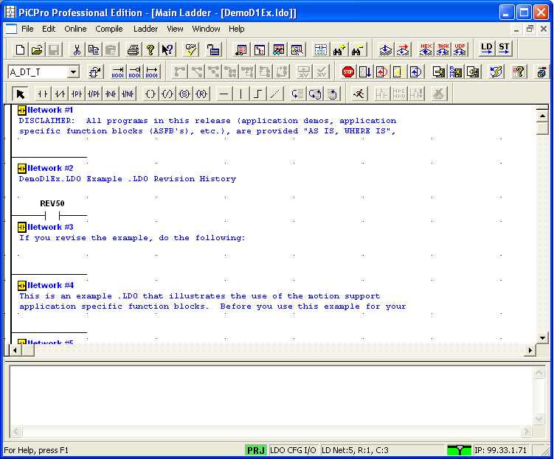

Step 3:
Select COMPILE, BIN FILE, COMPILE & DOWNLOAD from the main menu bar. Check the following selections and select OK. This will convert the LDO file into machine code and load it into the processor.

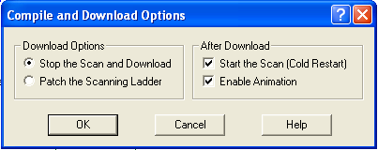
Note:
The OI_SER function block in the ladder is used to communicate serially with operator interfaces. More information can be obtained on this particular block by right clicking on the block in the ladder and selecting help.

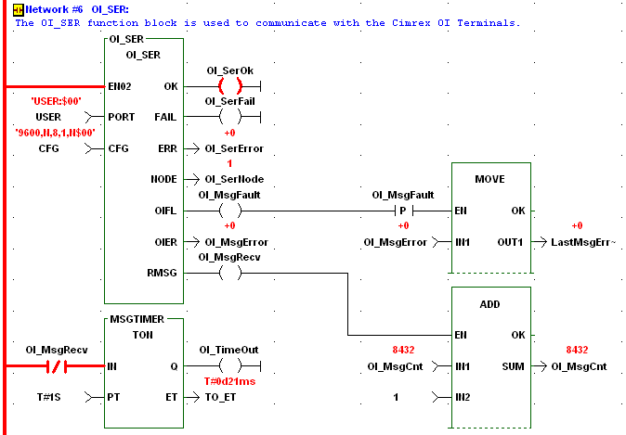
Note:
The software declarations list is where a global attribute is assigned to a variable allowing it to communicate with operator interfaces. To view the software declarations list select VIEW and SOFTWARE DECLARATIONS from the main menu bar. To assign a global attribute click in column A. and type in “G”. Another option would be to select TOOLS, MODIFY ATTRIBUTES, GLOBAL.

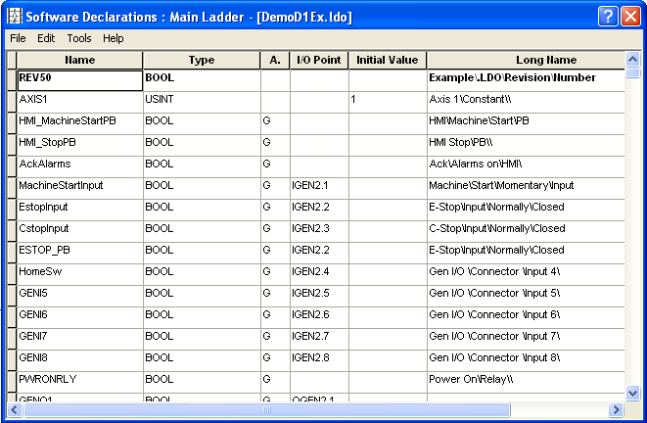

Note:
A file with an OID extension is generated with all of the variables assigned global attributes when the ladder is compiled and downloaded. This OID file must be imported into the HMI terminal anytime a global attribute or a communication driver is changed (i.e. change from serial to E-net). To construct the OID file or tag list select COMPILE and SETTINGS from the menu bar. A dialog box similar to the one below should appear. Check the box for construct data file and set the node number to a non-zero value. The output directory can be blank as the default is the same as the folder of the ladder file. Click OK to exit. The compile settings are saved in the project.

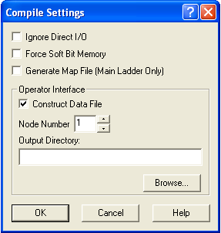

Step 4:
Close the PicPro program or Information Designer will not be able to access the serial port.
Connect Programming Cable (M.1302.8200) to PC and Exter Terminal.
***** Information Designer will not work with a USB to serial adapter*****
Open the following file with Information Designer:
C:\Program Files\G&L Motion Control\Applications V16.0.1\Examples\Digital MMC Smart Drive 1 Axis Sales Demo\DemD1T60c.cpa

Right click on DemD1T60c.cpa in the project manager and select PROPERTIES. A dialog box similar to the one below should appear. Select the operator terminal to match the model of the HMI. Set controller 1 brand to be G & L Motion Control and protocol to be G & L Motion Control Serial.

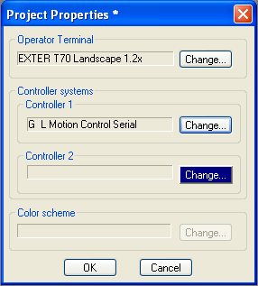
Step 5:
When the OK in the project properties is selected a dialog box with the following message may appear. Ignore the message and select OK.

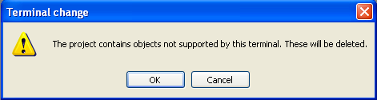

Step 6:
If the terminal has been changed in the project properties dialog box the following message will appear and YES should be selected.

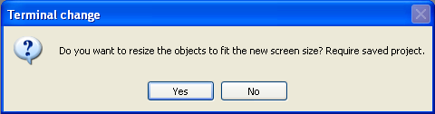

Step 7:
Save the project to the desired path and file name.
Note:
If any changes have been made to the global attributes of variables in the software declarations of the PiCPro file or the type of communications driver is changed the name list in Information Designer must be imported. This can be accomplished by selecting VIEW and NAME LIST from the main menu bar in Information Designer. A name list similar to the following will appear.

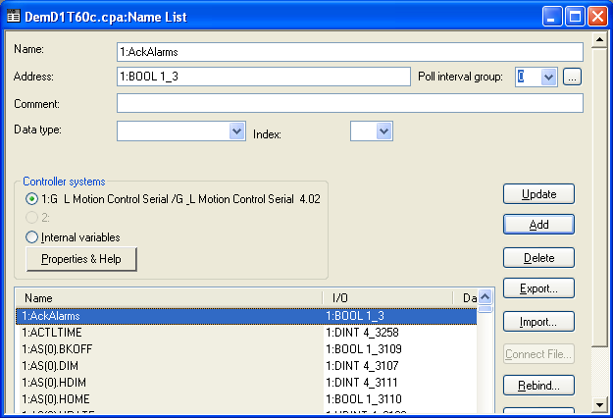

Select IMPORT on the name list. The following dialog box appears. Browse to the OID file to be imported. It is very important that the OID file is the file that was constructed by PiCPro.

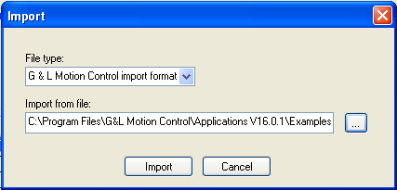
Select IMPORT on the import dialog box. The following dialog box should appear.

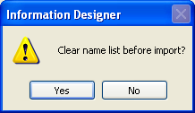

Click on YES to clear the name list before import. A dialog box similar to the following will appear. There should be zero lines rejected.

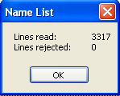

Select OK and the following dialog box will appear.

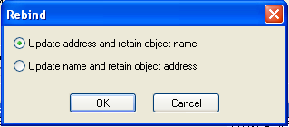

Check the update address and retain object name selection and select OK. Exit the name list by selecting EXIT on the name list dialog box. Save the project to the desired path and file name.
Note:
Even though the communication between the Exter terminal and DMMC is serial the Exter terminal could be assigned an IP address for downloading projects In the project manager of Information Designer expand the NETWORK COMMUNICATIONS folder. Right click on the first TCP/IP CONNECTIONS selection and select PROPERTIES. A dialog box similar to the one below should appear. Enter the desired IP address, Subnet mask, and Gateway of the Exter Terminal. Select OK in the TCP/IP Network Connection dialog box.

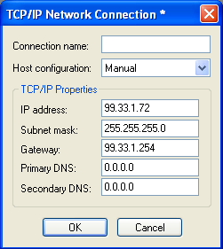
Step 8:
The project can now be transferred to the terminal. Select TRANSFER and COMMUNICATION PROPERTIES from the menu bar. The following dialog box should appear. Select the serial transfer method and click OK. If the Exter terminal was assigned an IP address from the note above the TCP/IP transfer method could be selected. Remember to connect an Ethernet cable to the PC and terminal

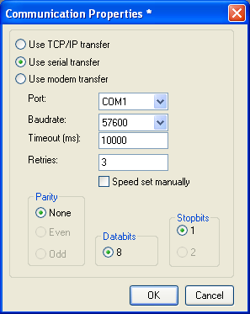
Step 9:
Next select TRANSFER and PROJECT from the menu bar. A project transfer dialog box will appear.

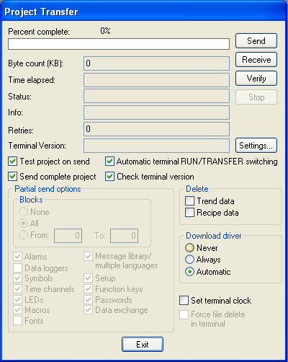

Step 10:
Select the SEND button and in the following dialog box select YES.

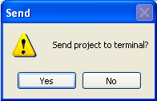
Step 11:
After the transfer indicates 100% complete as shown in the dialog box below select EXIT.

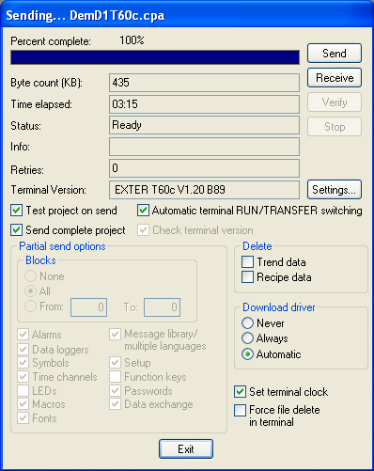

The project should now be loaded in the terminal. Connect the serial communication cable (M.1302.8453) between the Exter terminal and the DMMC. The two devices should begin to communicate with out any error messages on the Exter terminal.
Establishing Ethernet Communication with an Exter Terminal and DMMC

Step 1:
Connect Programming Cable (M.1302.8284) to PC and DMMC.
Open PicPro.
Select ONLINE, CONTROL OPERATIONS, CONFIGURE TCP/IP from the main menu bar. A dialog box similar to the one below will appear.

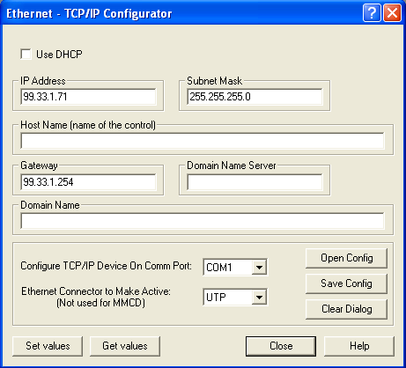

Step 2:
Enter the desired IP Address, Subnet Mask, and Gateway for the Digital MMC. Click the SET VALUES button. After the values are set in the MMC the following dialog box appears.

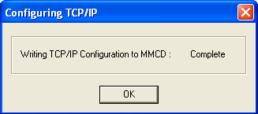
Step 3:
Click OK and close the Ethernet – TCP/IP Configurator dialog box.

Note:
The DMMC should now have the IP address that was assigned in the Ethernet – TCP/IP Configurator dialog box. This can be checked by clicking on the Microsoft START and RUN buttons. The run dialog box will appear.

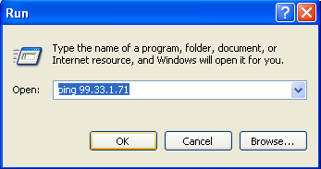

Type in the command “ping” and the IP address of the Digital MMC and click OK. If the IP address is recognized a dialog box with a “reply from” statement will appear. If the IP address is not recognized then a dialog box with a “request timed out” statement will appear.

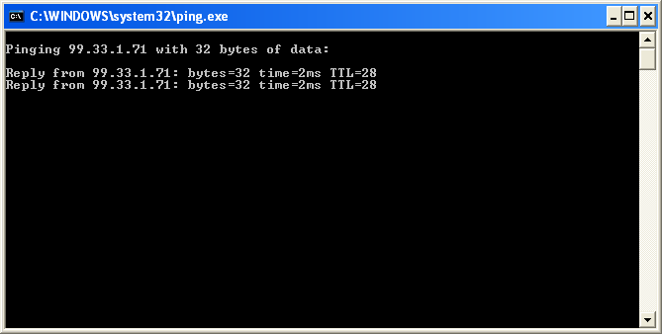

Note:
Once the IP address is set the controller could actually be downloaded via Ethernet. In this example the serial connection to PicPro will be used.
Step 4:
Open with PicPro
C:\Program Files\G&L Motion Control\Applications V16.0.1\Examples\Digital MMC Smart Drive 1 Axis Sales Demo\DemoD1Ex Pro Edition.PRJ

A project file similar to the one below will open. The folders can be expanded to provide information about the project. Three of the folders have been expanded in the example below.

Step 5:
Select WINDOW and MAIN LADDER from the main menu bar. The ladder or LDO file will appear similar to the one below.

Step 6:
Select COMPILE, BIN FILE, COMPILE & DOWNLOAD from the main menu bar. Check the following selections and select OK. This will convert the LDO file into machine code and load it into the processor.

Note:
The OPC_ENET function block in the ladder is used to communicate via Ethernet with operator interfaces. More information can be obtained on this particular block by right clicking on the block in the ladder and selecting help.

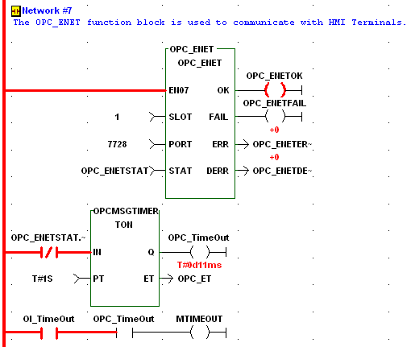
Note:
The software declarations list is where a global attribute is assigned to a variable allowing it to communicate with operator interfaces. To view the software declarations list select view and software declarations from the main menu bar. To assign a global attribute click in the column A. and type in “G”. Another option would be to select TOOLS, MODIFY ATTRIBUTES, GLOBAL.

Note:
A file with an OID extension is generated with all of the variables assigned global attributes when the ladder is compiled and downloaded. This OID file must be imported into the HMI terminal anytime a global attribute or the type of communications driver is changed (i.e. change from serial to E-net). To construct the OID file or tag list select COMPILE and SETTINGS from the menu bar. A dialog box similar to the one below should appear. Check the box for construct data file and set the node number to a non-zero value. The output directory can be blank as the default is the same as the folder of the ladder file. Click Ok to exit. The compile settings are saved in the project.

Step 7:
Close the PicPro program or Information Designer will not be able to access the serial port.
Connect Programming Cable (M.1302.8200) to PC and Exter Terminal.
***** Information Designer will not work with a USB to serial adapter*****
Open the following file with Information Designer:
C:\Program Files\G&L Motion Control\Applications V16.0.1\Examples\Digital MMC Smart Drive 1 Axis Sales Demo\DemD1T60c.cpa

Right click on DemD1T60c.cpa in the project manager and select PROPERTIES. A dialog box similar to the one below should appear. Select the operator terminal to match the model of the HMI. Set controller 1 brand to be G & L Motion Control and protocol to be G & L Motion Control Ethernet.

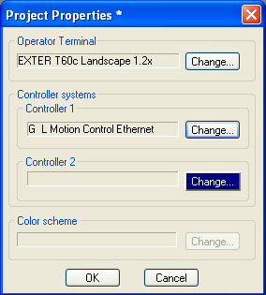
Step 8:
When the OK in the project properties is selected a dialog box with the following message may appear. Ignore the message and select OK.

Step 9:
If the terminal has been changed in the project properties dialog box the following message will appear and YES should be selected.

Step 10:
In the project manager of Information Designer expand the NETWORK COMMUNICATIONS folder. Right click on the first TCP/IP CONNECTIONS selection and select PROPERTIES. A dialog box similar the one below should appear. Enter the desired IP address, Subnet mask, and Gateway of the Exter Terminal. Select OK in the TCP/IP Network Connection dialog box.

Step 11:
In the project manager of Information Designer expand the PERIPHERALS folder. Right click on Controller 1 and select PROPERTIES. The following dialog box will appear. Enter the digital MMC IP address in IP Address 1 and select OK.

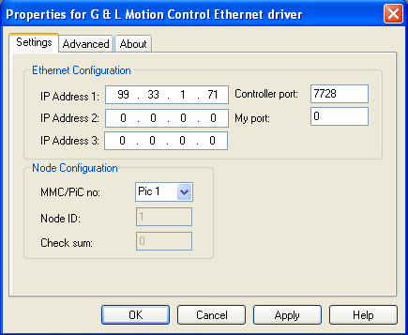

Step 12:
Save the project to the desired path and file name.
Note:
If any changes have been made to the global attributes of variables in the software declarations of the PiCPro file or the type of communications driver is changed the name list in Information Designer must be imported. This can be accomplished by selecting VIEW and NAME LIST from the main menu bar in Information Designer. A name list similar to the following will appear.

Select IMPORT on the name list. The following dialog box appears. Browse to the OID file to be imported. It is very important that the OID file is the file that was constructed by PiCPro.

Select IMPORT on the import dialog box. The following dialog box should appear.

Click on YES to clear the name list before import. A dialog box similar to the following will appear. There should be zero lines rejected.

Select OK and the following dialog box will appear.

Check the update address and retain object name selection and select OK. Exit the name list by selecting EXIT on the name list dialog box. Save the project to the desired path and file name.
Step 13:
The project can now be transferred to the terminal. Select TRANSFER and COMMUNICATION PROPERTIES from the menu bar. The following dialog box should appear. Select the serial transfer method and click OK.

Step 14:
Next select TRANSFER and PROJECT from the menu bar. A project transfer dialog box will appear.

Step 15:
Select the SEND button and in the following dialog box select YES.

Step 16:
After the transfer indicates 100% complete as shown in the dialog box below select EXIT.

The project should now be loaded in the terminal. Connect the Ethernet cable between the Exter terminal and the DMMC. The two devices should begin to communicate with out any error messages on the Exter terminal.
Initial Download of an Exter Terminal with Ethernet

Another method to initially load the Exter terminal is through Ethernet. First open the cover on the back of the terminal set dip switch 1 to 1 or ON. Set all other dip switches to 0 or OFF. See dip switch setting modes below.

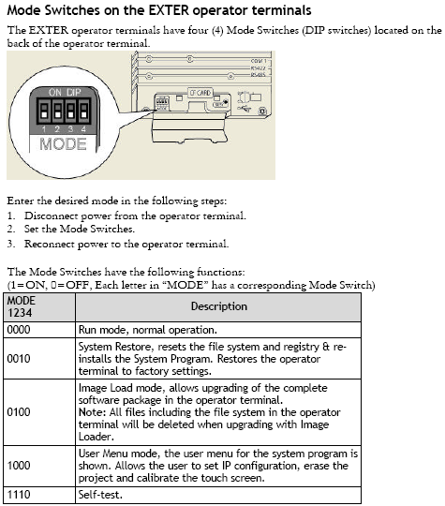

Cycle power on the terminal and complete the screen calibration process. Select TCP/IP SETTINGS on the service menu. Set DHCP to NO. The IP address and Subnet Mask can be set to the desired values (This method will not work if a gateway address is required). Set all the dip switch settings back to 0 or OFF and cycle power. After rebooting, the terminal should be at the Welcome screen and the IP address that was assigned should show in the lower left hand corner.
Connect an Ethernet cable to the PC and terminal. Open the project with Information Designer. Select TRANSFER and COMMUNICATION PROPERTIES on the main menu bar. In the following dialog box check use TCP/IP transfer method and click OK.

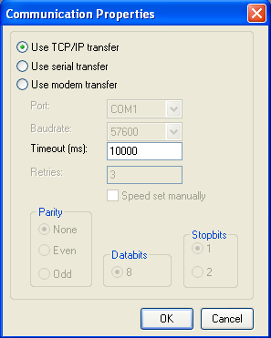
Next select TRANSFER and PROJECT from the menu bar in Information Designer. The following dialog box will appear.

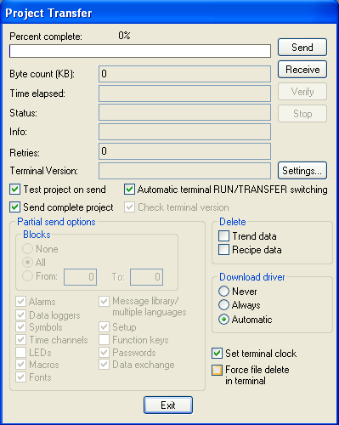
Click on SEND in the Project Transfer dialog box. The sending dialog box will appear. Enter the IP address of the Exter terminal in the Host address entry. This address must match the IP address entered at the service menu of the Exter terminal or the address that is indicted in the lower left hand corner of the Exter terminal.

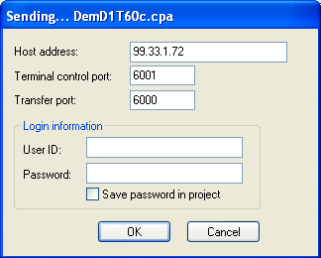
Click OK in the sending dialog box. Once the percent compete indicates 100% click on the EXIT button.

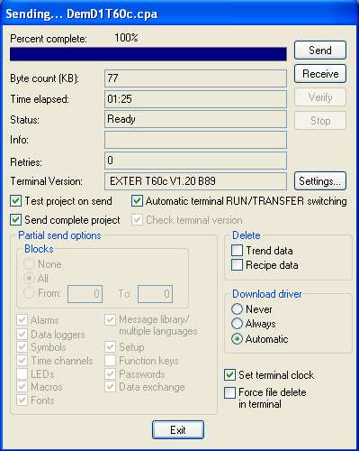

The project should be loaded in the Exter terminal. Connect the appropriate cables for the type of communication selected between the Exter terminal and the DMMC. The two devices should begin to communicate with out any error messages on the Exter terminal.

Application Tips and Troubleshooting

Runtime Errors

There are two types of runtime errors, local errors, i.e. errors generated by the Exter Terminal and remote errors, i.e. errors generated by the Digital MMC controller.

Local Errors

Comm. Error: This error is generated when the Exter Terminal does not get a response from the controller. The following is a list of possible causes and solutions:
- Cable is not connected or wired wrong. The following are the correct connections between the Exter Terminals and Digital MMC Controllers.

RS232:

RS422:

- Digital MMC ladder does not have the OI_SER ASFB for serial communications or OPC_ENET ASFB for Ethernet communications. Refer to the PiCPro Online help or the Function/Function Block Reference Guide for more information on these functions. Note you can copy networks that have these functions, from the sample ladders into your ladder.
- The Node number under the compile settings does not match the node number in the OID file that you imported into the Exter project. When you install PiCPro the node ID is set to the default value of 0. It must be set to 1 – 255. Check to make sure the node number under the Setup-Peripherals-Driver Configuration to make sure it matches the setting under the PiCPro Compile-Options window as show above in Step 6 of the Getting Started Section.

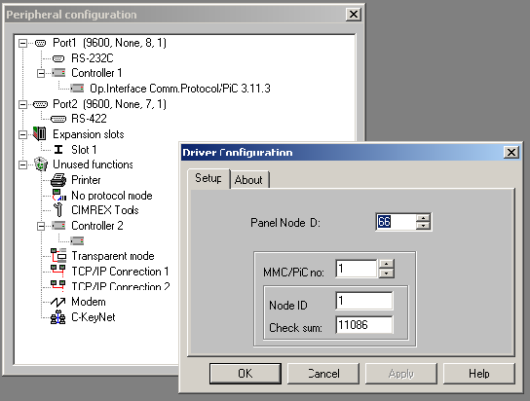

Revision History

Date: [January 26, 2007]
Author: [Alan Geiger]
Changes: Original

Date: [For each revision, enter the date revised,]
Author: [the name of the person revising the document,]
Changes: [and indicate what changes were made.]

